Table Design and Data Flow Diagram

JINS MATHEW

ROLLNO: 16

Guide in Charge: Asst. Pro. T J Jobin

Computer Application Dept.

Project Name: MovieHunter

Table Design

1. Table Name: tbl_UserLogin

Primary Key: LoginId

|  |  |  |  |
| --- | --- | --- | --- |
| No | Field name | Data type | Description |
| 1 | Login_Id | Int(40) | Primary key |
| 1 | User_Name | Varchar(30) | Username |
| 2 | Password | Varchar(30) | Password |
| 3 | User_Type | Int(2) | User type |
| 5 | Status | Int(2) | Status |

1. Table Name: tbl_Users

Primary Key: User_Id

Foreign Key: Username from tbl_UserLogin

District_Id from tbl_District

|  |  |  |  |
| --- | --- | --- | --- |
| **No** | **Field name** | **Data type** | **Description** |
| **1** | Login_Id | Varchar(30) | Userid |
| **2** | User_Id | Int(40)Varchar(30) | Foreignkey |
| **3** | Fname | Varchar(30) | First name |
| **4** | Lname | Varchar(30) | Last name |
| **5** | District_Id | Varchar(30) | District |
| **6** | Place | Varchar(30) | Place |
| **7** | Phone | Varchar(50) | Phone number |
| **8** | Email | Varchar(50) | Email |
| **9** | Profile_Pic | Varchar(30) | Path of the profile pic |
| **10** | Status | Int(2) | Status |
| **11** | Type | Int(5) | type |

3. Table Name: tbl_Theater

Primary Key: Theater_Id

Foreign Key: LoginId from tbl_ UserLogin

|  |  |  |  |
| --- | --- | --- | --- |
| No | Field name | Data type | Description |
| 1 | Theater_Id | Int(40) | Primary Key |
| 2 | Login_Id | Int(255) | Foreign Key |
| 3 | Place_Id | Varchar(50) | Foreign Key |
| 4 | Th_Name | Varchar(50) | Name |
| 6 | Th_Ph1 | Varchar(30) | Phone number |
| 7 | Th_Ph2 | Varchar(50) | Phone number |
| 8 | Th_Email | Varchar(50) | Email |
| 9 | Profile_Pic | Varchar(50) | Profile picture |
| 10 | Status | Int(2) | Status |

4.Table Name: tbl_Trailers

Primary Key: Tr_Id

Foreign Key: User_Id from tbl_Users

|  |  |  |  |
| --- | --- | --- | --- |
| No | Field name | Data type | Description |
| 1 | Tr_Id | Int(60) | Trailer id |
| 2 | User_Id | Int(40) | Foreign Key |
| 3 | Mov_Name | Varchar(30) | Movie name |
| 4 | Tr_Video | Varchar(200) | Path of video |
| 5 | Mov_Pic | Varchar(60) | Path of the poster of movie |
| 6 | Th_Seats | Int(10) | Total seats in the theater |
| 7 | Status | Int(5) | Status |
| 8 | Admin | Int(5) | Admin approve |

5. Table Name: tbl_Casts

Primary Key: Tr_Cast_Id

Foreign Key: Tr_Id from tbl_Theaters

Act_Id from tbl_Actors

|  |  |  |  |
| --- | --- | --- | --- |
| No | Field name | Data type | Description |
| 1 | Tr_Cast_Id | Int(255) | Priary Key |
| 2 | Tr_Id | Int(255) | Foreign Key |
| 3 | Act_Id | Int(255) | Actor Id |

6. Table Name: tbl_Actors

Primary Key: Act_Id

|  |  |  |  |
| --- | --- | --- | --- |
| No | Field name | Data type | Description |
| 1 | Act_Id | Int(255) | Place id |
| 2 | Act_Name | Varchar(50) | District name |

7. Table Name: tbl_Districts

Primary Key: Dist_Id

|  |  |  |  |
| --- | --- | --- | --- |
| No | Field name | Data type | Description |
| 1 | Dist_Id | Int(255) | Place id |
| 2 | Dist_Name | Varchar(50) | District name |

8. Table Name: tbl_Places

Primary Key: Place_Id

Foreign Key: Dist_Id from tbl_Districts

|  |  |  |  |
| --- | --- | --- | --- |
| No | Field name | Data type | Description |
| 1 | Place_Id | Int(255) | Place id |
| 2 | Dist_Id | Int(255) | District id |
| 3 | Place_Name | Varchar(30) | Place name |

9. Table Name: tbl_Reviews

Primary Key: Review_Id

Foreign Key: Tr_Id from tbl_Trailers

User_Id from tbl_Users

|  |  |  |  |
| --- | --- | --- | --- |
| No | Field name | Data type | Description |
| 1 | R_Id | Int(255) | Review id |
| 2 | Tr_Id | Int(60) | Trailer id |
| 3 | User_Id | Int(40) | User id |
| 4 | R_Data | Varchar(700) | Data |
| 5 | Status | Int(5) | Status |
| 6 | Admin | Int(5) | Admin aproove |

10. Table Name: tbl_Shows

Primary Key: Show_Id

Foreign Key: Tr_Id from tbl_Trailers

Th_id from tbl_Theater

|  |  |  |  |
| --- | --- | --- | --- |
| No | Field name | Data type | Description |
| 1 | Show_Id | Int(10) | Show id |
| 2 | Th_Id | Int(10) | Theater id |
| 3 | Tr_Id | Int(10) | Trailer id |
| 4 | Sh_Time | Int(10) | Show time |
| 5 | Open_Date | varchar(10) | Open date |
| 6 | Close_Date | varchar(10) | Close date |
| 7 | Seat_Cost | Int(25) | Cost of seat |
| 8 | Status | Int(10) | status |

11. Table Name: tbl_ShowDates

Primary Key: Date_Id

Foreign Key: Show_Id from tbl_Shows

|  |  |  |  |
| --- | --- | --- | --- |
| No | Field name | Data type | description |
| 1 | Date_Id | Int(255) | Primry Key |
| 2 | Show _Id | Int(255) | Show id |
| 3 | Cdate | Varchar(40) | Calender date |
| 4 | Tot_Seats | Int(255) | Total number of seats |
| 5 | Booked_Seats | Int(255) | Booked seats |

12. Table Name: tbl_Booking

Primary Key: Book_Id

Foreign Key: Login_Id from tbl_Userlogin

|  |  |  |  |
| --- | --- | --- | --- |
| No | Field name | Data type | Description |
| 1 | Book_Id | Int(255) | Book id |
| 2 | Login_Id | Varchar(30) | Username |
| 3 | Show_Id | Int(255) | Show id |
| 4 | Book_Date | Varchar(30) | Booked date |
| 5 | Total_Cost | Int(255) | Total cost |

Show_Id from tbl_Shows

13. Table Name: tbl_BookedSeats

|  |  |  |  |
| --- | --- | --- | --- |
| No | Field name | Data type | Description |
| 1 | Bk_Seat_id | Int(255) | Primary Key |
| 2 | Book_Id | Int(255) | Booking id |
| 3 | Seat_Id | Int(255) | Seat number |

Foreign Key: book_id from booking

14. Table Name: tbl_Cart

Primary Key: Seat_No

Foreign Key: Login_Id

|  |  |  |  |
| --- | --- | --- | --- |
| No | Field name | Data type | Description |
| 1 | Seat_no | Int(255) | Seat Number |
| 2 | Login_Id | Int(255) | Foreign Key |

15. Table Name: tbl_ThPredict

Primary Key: Pred_Id

Foreign Key: Login_Id from tbl_UserLogin

Th_Id from tbl_Theaters

|  |  |  |  |
| --- | --- | --- | --- |
| No | Field name | Data type | Description |
| 1 | Pred_Id | Int(255) | Primary Key |
| 2 | Login_Id | Int(255) | Foreign Key |
| 3 | Th_Id | Int(255) | Foreign Key |

16. Table Name: tbl_ActorPredict

Primary Key: Act_Pred_Id

Foreign Key: Login_Id from tbl_UserLogin

Act_Id from tbl_Actors

|  |  |  |  |
| --- | --- | --- | --- |
| No | Field name | Data type | Description |
| 1 | Act_Pred_Id | Int(255) | Primary Key |
| 2 | Login_Id | Int(255) | Foreign Key |
| 3 | Act_Id | Int(255) | Foreign Key |

Data Flow Diagram

Level - 0 Diagram for MovieHunter

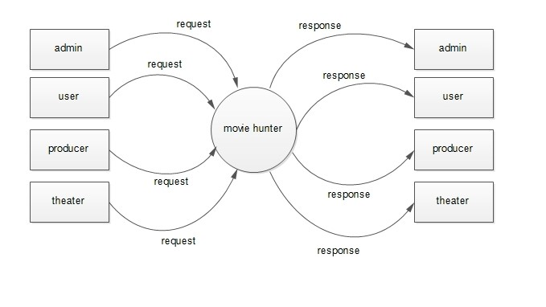

Level – 1 Diagram for MovieHunter – Admin

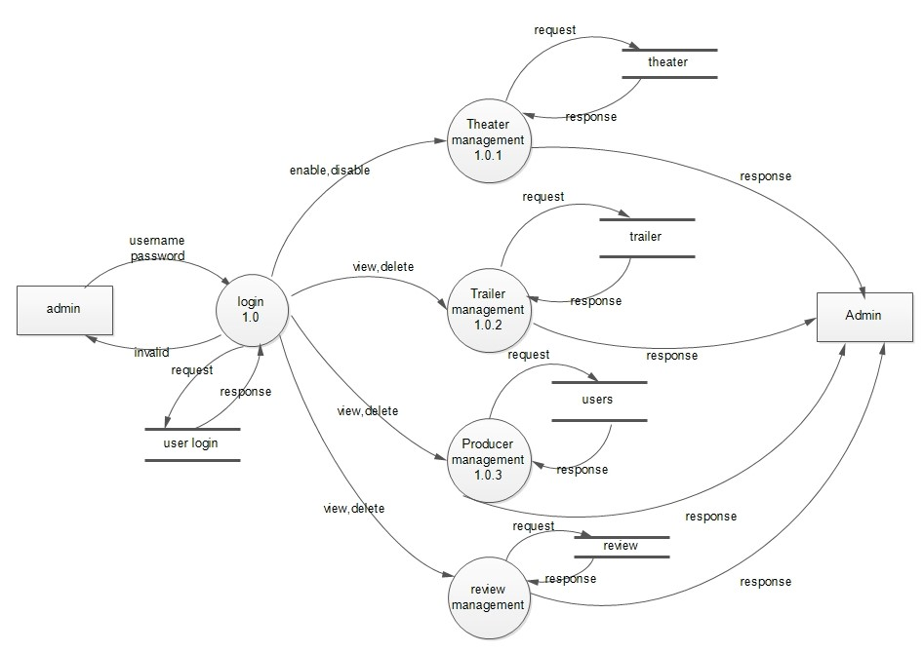

Level – 1 Diagram for MovieHunter – Producer

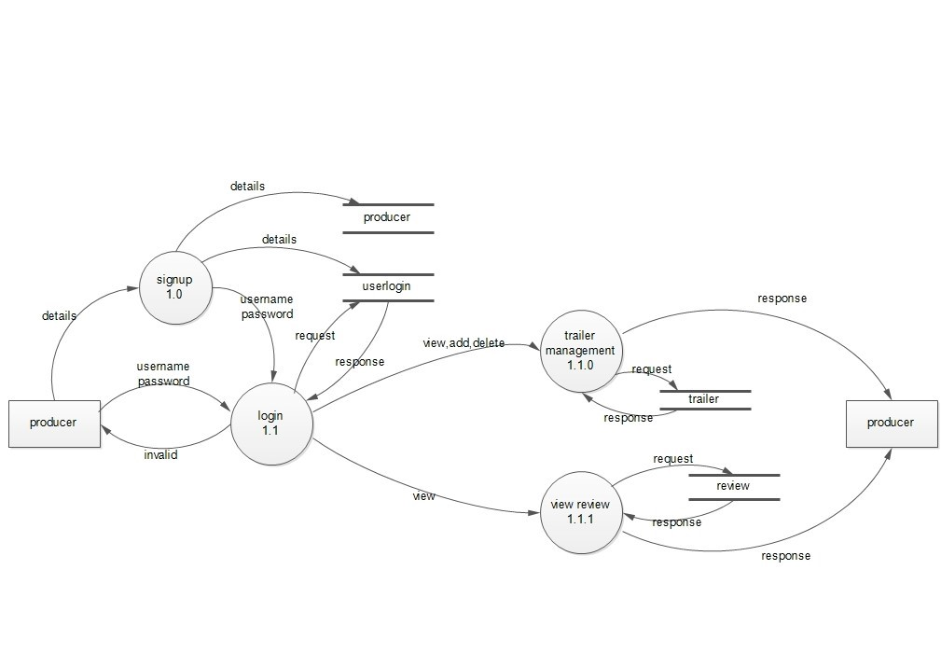

Level – 1 Diagram for MovieHunter – Theater

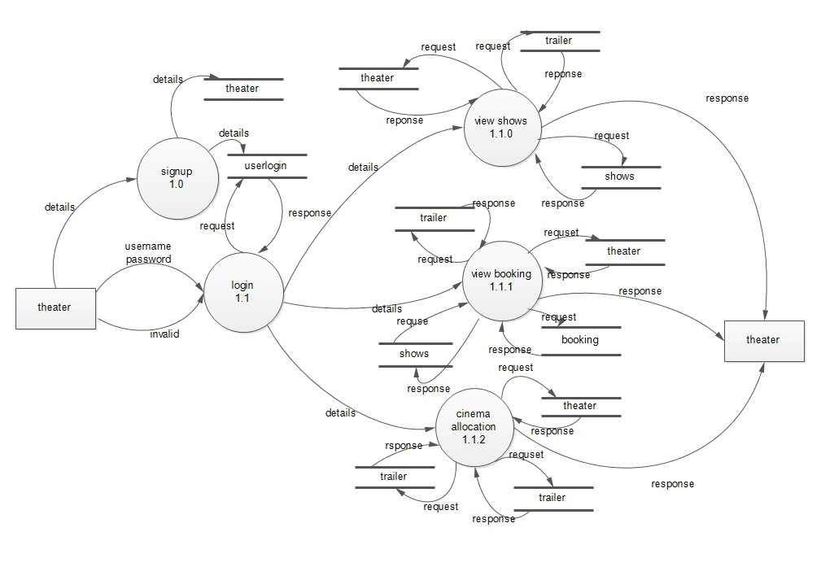

Level – 1 Diagram for MovieHunter – Users

